Day 2
Databricks in Action: Retail Sales Analytics Using Unity Catalog, SQL, Genie, and AI/BI Dashboards
1. Introduction
Data analytics plays an important role in helping businesses understand their performance, identify trends, and make informed decisions.
As part of the Data Engineering Foundations and Databricks learning challenge, I built a Retail Sales Analytics solution using Databricks. The project involved organizing sales data with Unity Catalog, analyzing business performance using SQL, exploring AI-assisted insights with Databricks Genie, and creating an interactive dashboard using Databricks AI/BI Dashboards.
This hands-on project helped me understand how data organization, SQL analytics, AI-assisted analysis, and visualization can work together to transform raw sales data into meaningful business insights.
2. Project Objectives
The main objectives of this project were:
- Organize retail sales data using Unity Catalog.
- Analyze overall sales performance using Databricks SQL.
- Identify top-performing products and regions.
- Understand monthly sales trends.
- Calculate product category revenue contributions.
- Explore business questions using Databricks Genie.
- Validate AI-generated answers against manually written SQL queries.
- Build an interactive dashboard to visualize important sales metrics.
3. Tools and Technologies
The following tools and technologies were used in this project:
- Databricks: The platform used to perform data analysis and build the dashboard.
- Unity Catalog: Used to organize the sales data into a catalog, schema, and table.
- Databricks SQL: Used to answer business questions and calculate sales metrics.
- Databricks Genie: Used to explore business questions through natural-language prompts.
- Databricks AI/BI Dashboards: Used to visualize key performance indicators, regional sales, category revenue, monthly trends, and top products.
- Retail Sales Dataset: The dataset used for the analysis.
4. Dataset Overview
The project uses a retail sales dataset containing 1,000 sales records and 100 distinct products.
The dataset includes information about products, transaction dates, sales representatives, regions, sales amounts, quantities sold, product categories, unit costs, unit prices, customer types, discounts, payment methods, and sales channels.
The main columns used in the analysis were:
Column | Purpose
Product_ID | Identifies each product
Sale_Date | Supports monthly sales analysis
Region | Enables regional performance comparisons
Sales_Amount | Represents the recorded sales amount
Quantity_Sold | Measures the number of units sold
Product_Category | Supports category-level analysis
Sales_Channel | Identifies the sales channel
For revenue calculations, I used the recorded Sales_Amount field rather than recalculating revenue from quantity and unit price.
5. Data Organization Using Unity Catalog
Unity Catalog helped organize the sales dataset into a structured hierarchy.
The table was organized as follows:
Innomatics → default → sales_dataset
- Catalog: Innomatics
- Schema: default
- Table: sales_dataset
A catalog is the top-level container, a schema organizes related database objects, and a table stores the actual data in rows and columns.
This structure makes data easier to locate, manage, and use in SQL queries.
Screenshot 1: Unity Catalog
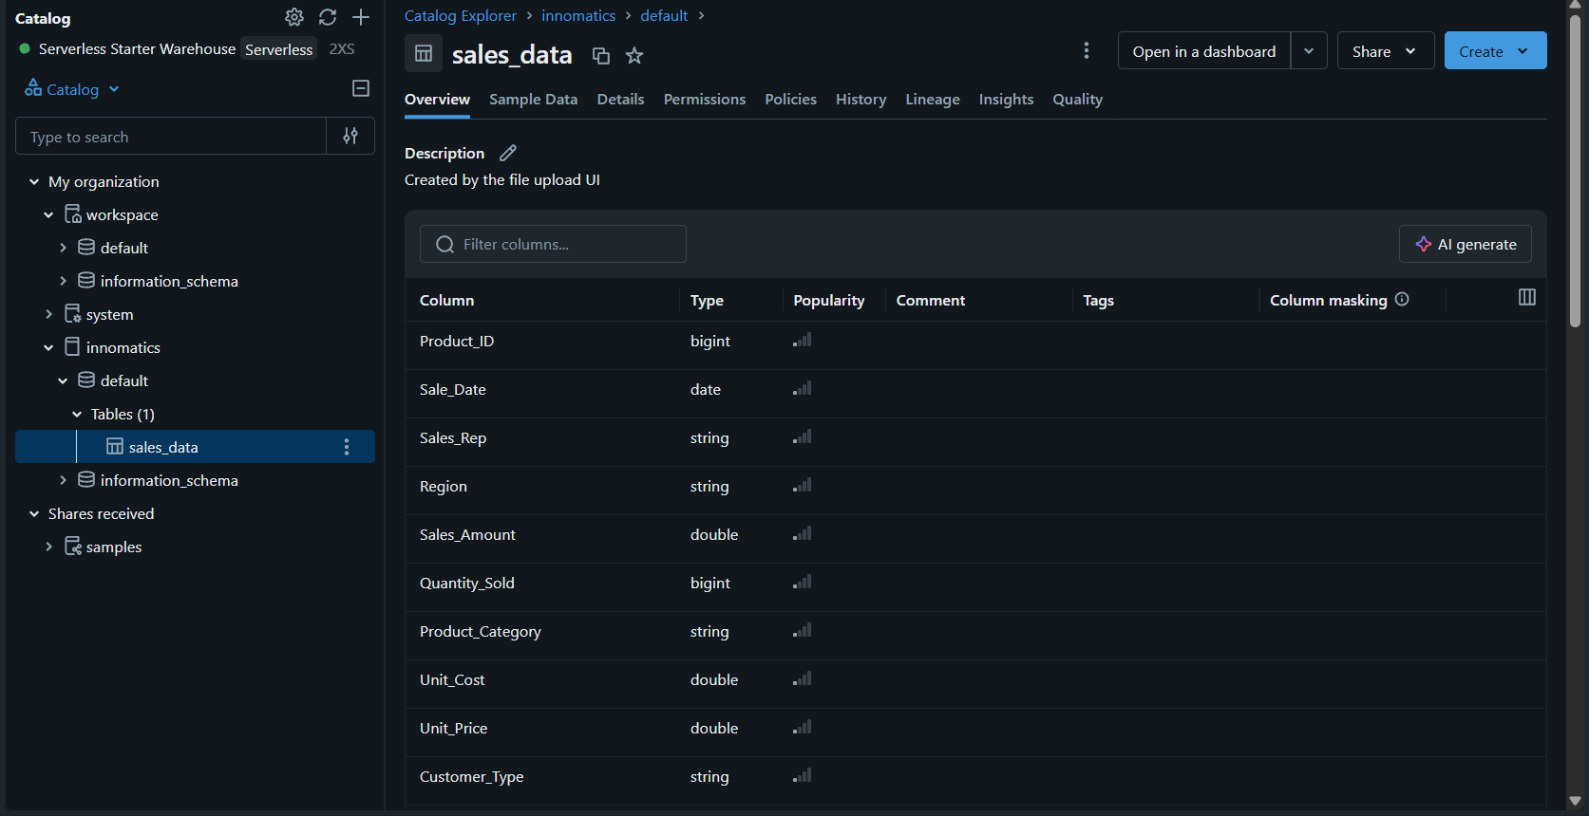
Screenshot 2: Sample Records
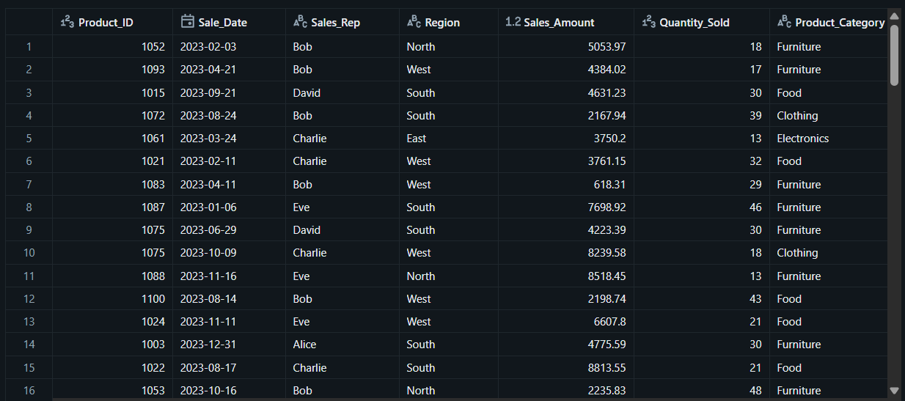
6. Business Analysis Using Databricks SQL
I used Databricks SQL to answer five business questions about the retail sales dataset.
Question 1: What Is the Overall Sales Performance?
The first query calculates total recorded sales revenue, total quantity sold, the number of sales records, and the number of distinct products.
SQL Query
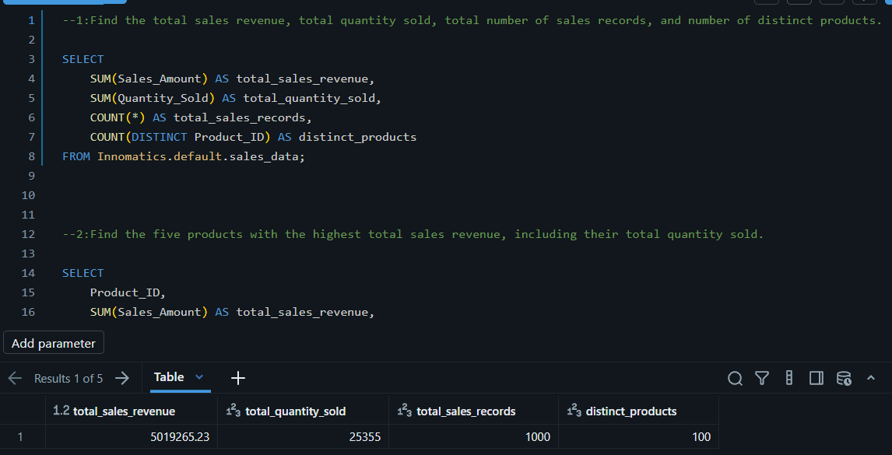Question 2: Which Five Products Generated the Highest Revenue?
This query identifies the five products with the highest total recorded sales revenue and calculates the total quantity sold for each product.
SQL Query
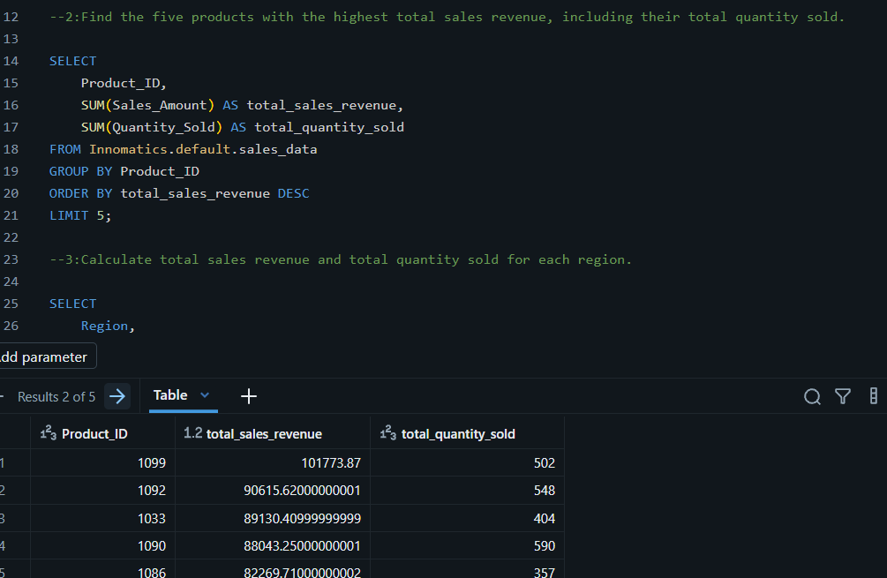
Question 3: Which Region Generated the Highest Revenue?
This query groups the sales records by region and calculates total revenue and quantity sold for each region.
SQL Query
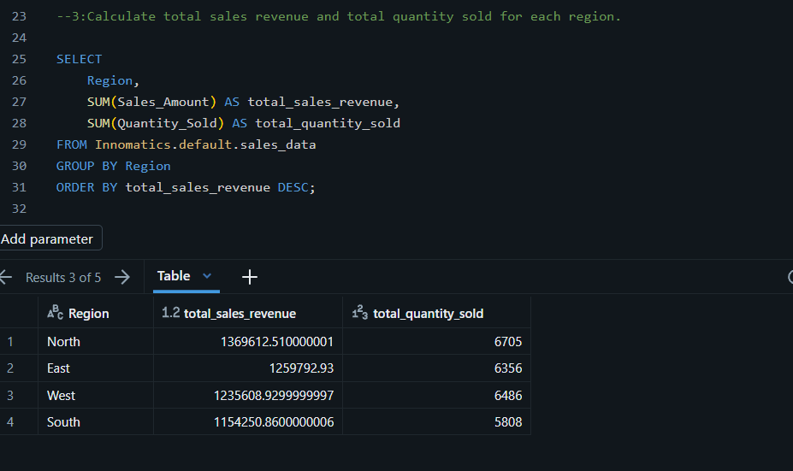
Question 4: How Does Sales Revenue Change Monthly?
This query calculates the total recorded sales revenue for each month using the Sale_Date column.
SQL Query
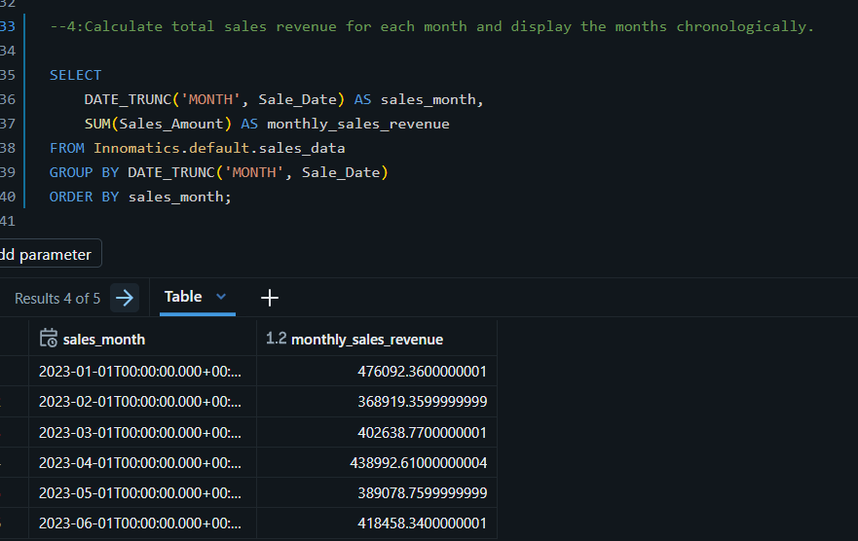
Question 5: Which Product Category Contributed the Most Revenue?
This query calculates recorded sales revenue for each product category and determines its percentage contribution to total revenue.
SQL Query
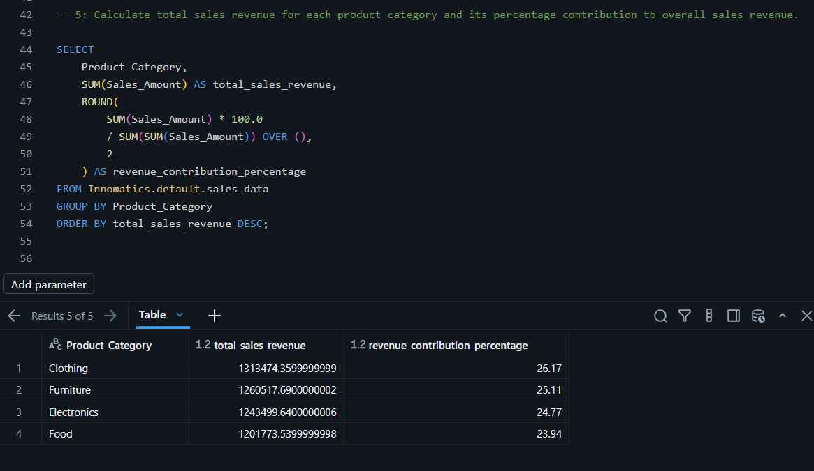
7. AI-Assisted Business Analysis Using Databricks Genie
After completing the SQL analysis, I used Databricks Genie to explore the sales data through natural-language questions.
I asked questions such as:
- Which five products generated the highest total sales revenue?
- Which region generated the highest recorded sales revenue?
- Which product category contributed the most to total sales?
Genie returned analytical responses that included revenue comparisons and product, regional, and category insights.
Comparing Genie with SQL
I compared Genie's answers with the results of my manually written SQL queries.
Regional performance: Genie identified North as the highest-revenue region, with 1,369,612.51. This matches my SQL result.
Product category contribution: Genie identified Clothing as the highest-revenue category, with 1,313,474.36. This also matches my SQL result.
Top-five products: Genie's initial answer differed from my SQL results. My SQL query ranked Product 1099 first, while Genie reported Product 1089 first.
This difference highlights the importance of validating AI-generated answers. The underlying SQL, table selection, aggregation logic, and data source should be checked before accepting an AI-generated result.
Key Learning
Databricks Genie makes it easier to explore business questions using natural language. However, its answers should be checked against manually written SQL queries and the correct dataset before they are used to support business decisions.
Screenshot 8: Genie Questions and Responses
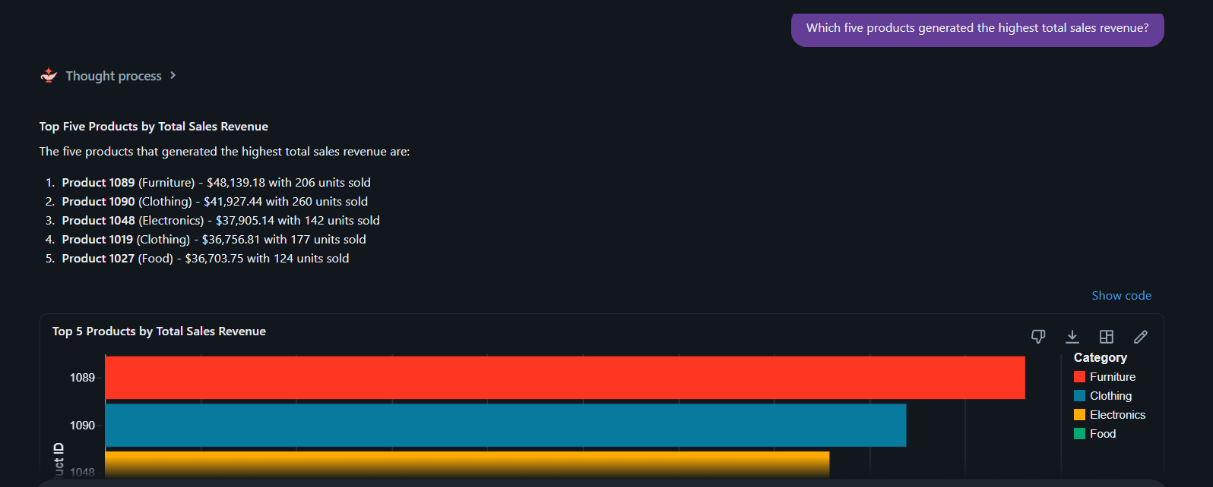Screenshot 9: SQL Validation
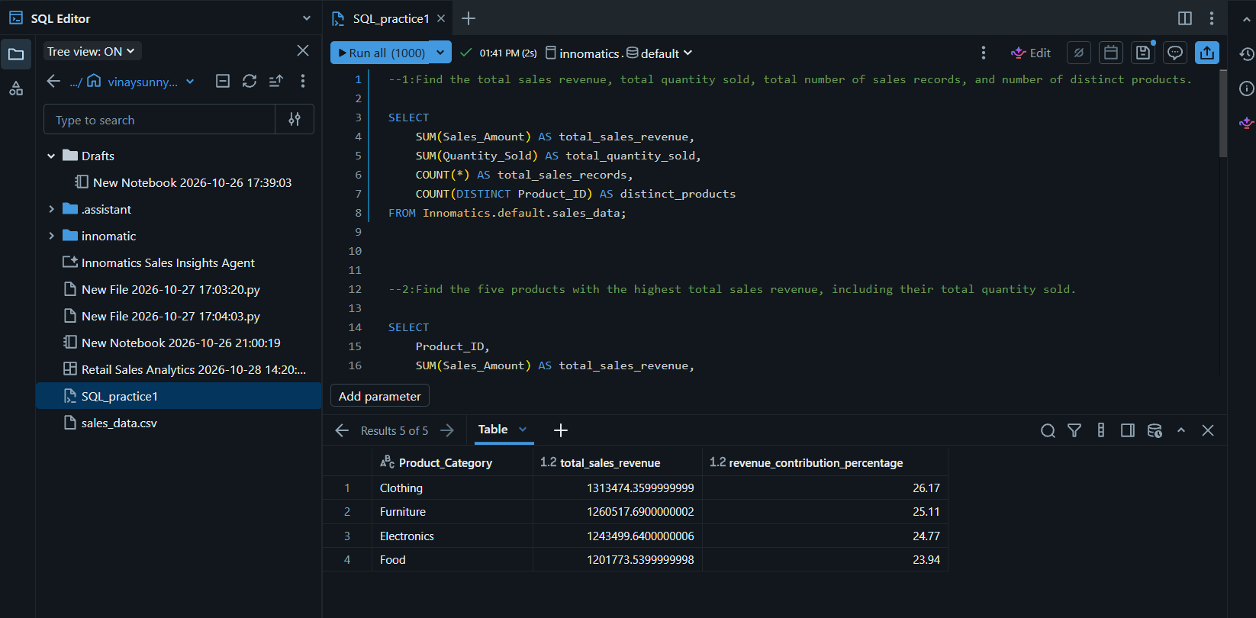
8. Building the AI/BI Dashboard
To make the analysis easier to understand, I created an interactive Retail Sales Analytics Dashboard using Databricks AI/BI Dashboards.
The dashboard brings together key metrics and visualizations in one place.
KPI Cards
The dashboard includes four KPI cards:
- Total Sales Revenue
- Total Quantity Sold
- Total Sales Records
- Distinct Products
These cards provide a quick overview of the sales dataset.
Visualizations
The dashboard includes four charts:
- Sales Revenue by Region: Compares revenue across the North, East, West, and South regions.
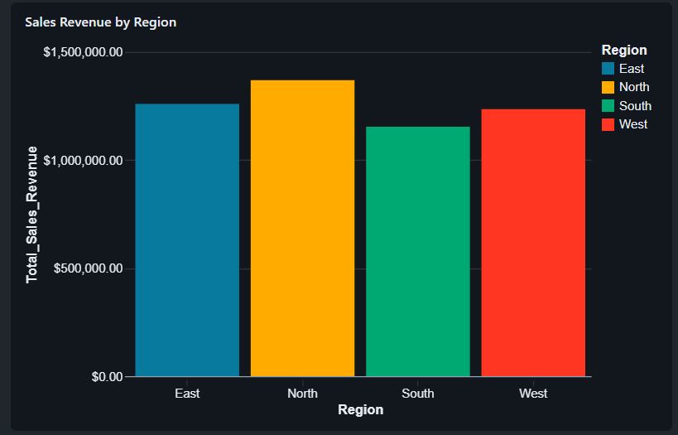

- Sales Revenue by Product Category: Shows the revenue contribution of each category.
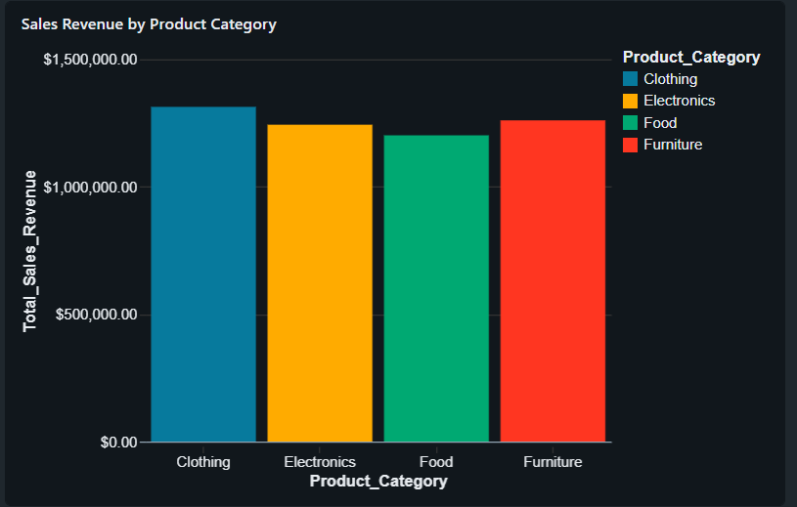
- Monthly Sales Revenue: Displays changes in recorded sales revenue over time.
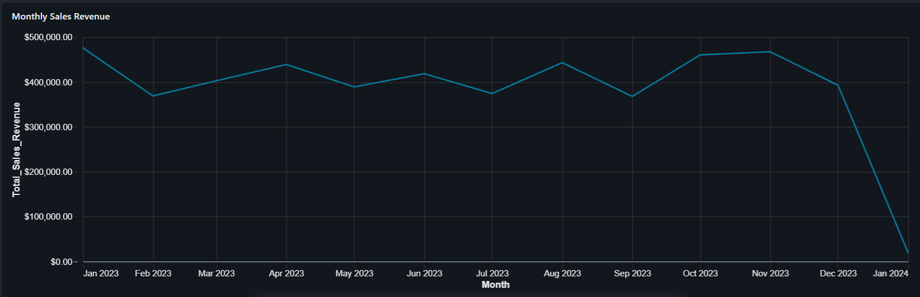
- Top 10 Products by Sales Revenue: Compares the highest-revenue products.
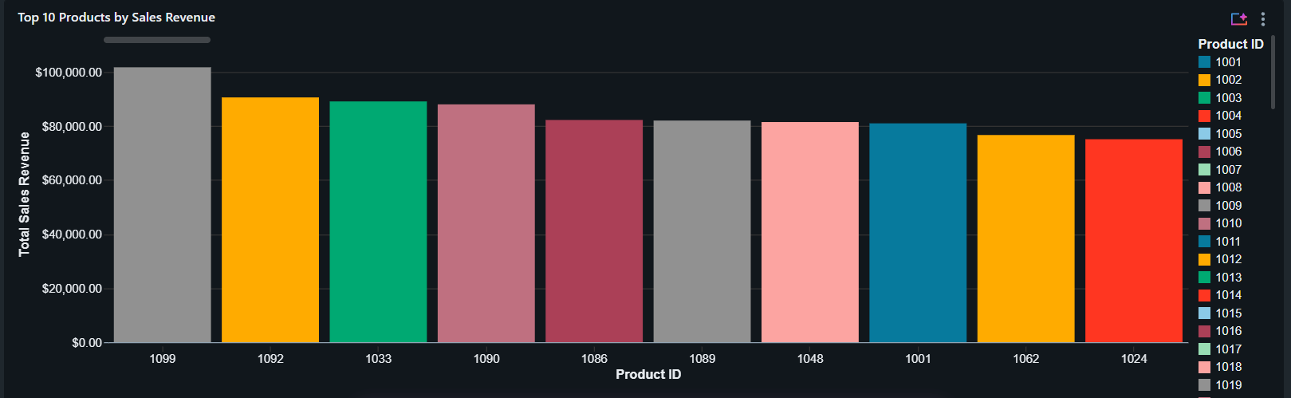

Interactive Filters
I added filters for:
- Region
- Product Category
- Sale Date
These filters allow users to explore the dashboard based on selected values and date ranges.
The dashboard brings together the results of the SQL analysis and makes the findings easier to explore visually.
9. Key Findings
Based on the manually executed SQL queries, the project produced the following findings:
- Total recorded sales revenue: 5,019,265.23.
- Total quantity sold: 25,355 units.
- Total sales records: 1,000.
- Distinct products: 100.
- Highest-revenue region: North, with 1,369,612.51.
- Highest-revenue product category: Clothing, with 1,313,474.36.
- Highest-revenue product: Product 1099, with 101,773.87.
- Monthly sales trend: Recorded revenue fluctuated across the months shown in the query output.
The analysis demonstrates how SQL can be used to examine overall sales performance, identify leading products, compare regions, and measure category contributions.
Genie's regional and category findings matched the SQL results, while its initial top-five product result differed and required further validation.
10. Challenges and Learnings
During this project, I gained practical experience in organizing data, writing SQL queries, exploring AI-assisted analytics, and building an interactive dashboard.
My main learnings were:
- Unity Catalog provides a structured way to organize and access data.
- SQL aggregation and grouping can answer important business questions.
- Monthly analysis helps reveal changes in sales performance over time.
- Percentage calculations help compare category contributions.
- Databricks Genie enables natural-language exploration of business data.
- AI-generated answers should be validated against SQL results.
- Dashboards make analytical findings easier to understand and communicate.
One important challenge was the difference between Genie's top-five product results and the manually calculated SQL results. This reinforced the importance of checking data sources and query logic before accepting AI-generated insights.
11. Conclusion
This project provided hands-on experience building a Retail Sales Analytics solution using Databricks.
By combining Unity Catalog, Databricks SQL, Genie, and AI/BI Dashboards, I explored how retail sales data can be organized, analyzed, validated, and presented through interactive visualizations.
The project strengthened my understanding of SQL-based business analysis and responsible AI-assisted data exploration. It also gave me practical experience that I can continue building on as I develop my skills in data analytics and data engineering.
12. Project Resources
- Databricks Dashboard: [https://dbc-680681f5-fcd4.cloud.databricks.com/dashboardsv3/01f1d2acafab15d9a4cf61bbff7c0d71/published?o=7474652199351496]

